**Lab 1 Windows Command-Line**

**Student: Ektelat Mohamad.**

**ID: 208223826.**

**Question 1:**

* Mkdir: To create a directory.
* cd: Displays the name of the current directory or changes the current directory.
* cd..: When typing this command, you will return to the root directory.
* move: used to move files and folders/directories.
* copy: Copies or appends files. Files can be copied with the same name or with a new name.
* dir:  lists all files and subdirectories contained in a specific directory.

**Question 2:**

**Question 3:**

**Question 4:**

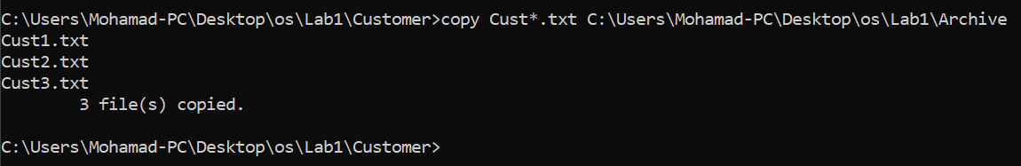

**Question 5:**

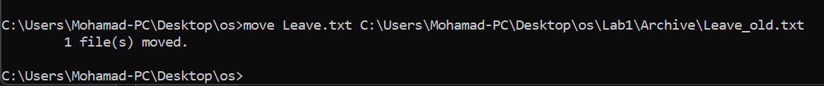

**Question 6:**

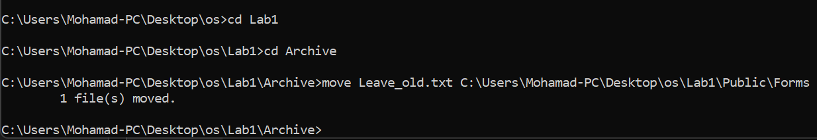

**Question 7:**

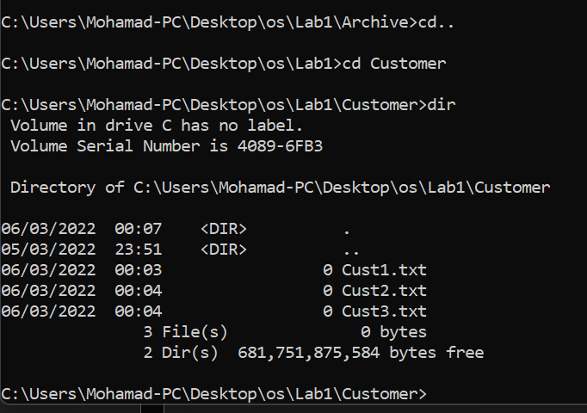

**Question 8:**

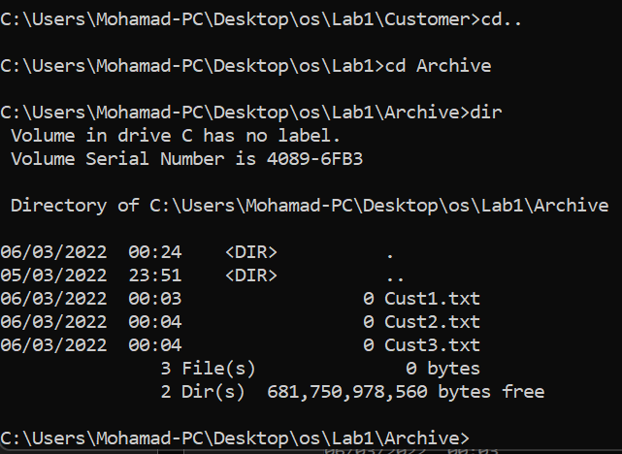

**Question 9:**

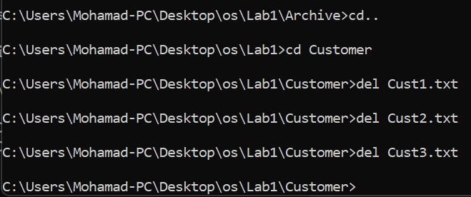

**Question 10:**

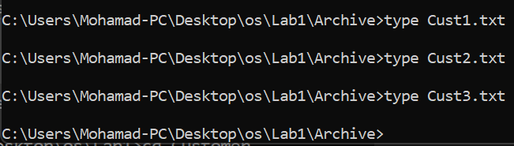

**Question 11:**

* Using the command “cls”.

1. TIME.
2. DATE.
3. Time.
4. Date.
5. Nothing.
6. Back to the root.
7. The cmd shows you the content of the folder.
8. Displays the listing in wide format, with as many as five file names or directory names on each line.
9. /n